Project Description-The project selected is the washing machine. The system will show the time remaining on a cycle whenever a certain task is picked on it. There is also going ot be a counter that handles the lid being open to too long. If the lid of the washing machine is on for too long, the system will register an error. The leds will show the current cycle as well as other status information. The status information could be the certain washing modes or something of the sort. Buttons and switches will be used for doors, coins, and any other modes within the washing machine.

For the project the inputs on the board will be for the coins,reset, timer, and mode selection. The fsm will handle all those function and the counter will make sure anything that deals with time has a signal to deal with and be able to stop or continue counting

Block diagram-

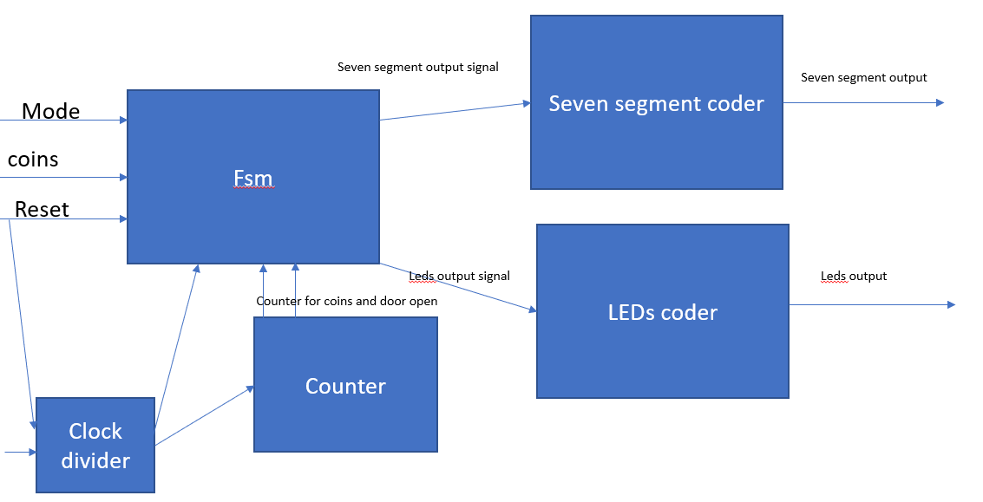

Detailed time line

|  |  |
| --- | --- |
| Date | Task |
| November 12, 2020 | Turn in Project spec and Rough draft |
| November 17,2020 | Major component due |
| November 18,2020 | Work on trying to complete the rest of design mainly the fsm |
| November 19,2020 | Working on timing |
| November 21,2020 | Work on top level |
| November 22,2020 | Test design |
| November 24, 2020 | Majority of major components due |
| December 1,2020 | Finish up reset of the design and start documentation |
| December 8,2020 | Turn in everything |